New York Advisory Board – February’s Lightning update!

EPF LOBBY DAY – FEB 12: With Jessica’s amazing leadership, many groups braved a snow storm to meet with elected officials in Albany. In total, 130 offices were met with! Some that could not attend, like Grassroots Gardens, BQLT, Manhattan and Bronx land trusts are tee-ing up district visits to carry forth our message.
NYSCPP: In mid- February, the New York State Conservation Partnership Program (NYSCPP) Grants Review Committee met to discuss the 2018-19 round of grant applications.
In all, the committee reviewed 88 applications totaling $3,233,926 in request from 55 land trusts across the state (including 3 first time applicants). The committee left the meeting with a list of funding recommendations. Katrina and Meme will be following up with applicants. A final roster of recommended grant projects and award amounts will be submitted to DEC by in March.
The official announcement of grant awards will be made in late April at a press event hosted by DEC (date, time TBD).
DEC: In early February, Meme, Kevin and Jeff Jones met with DEC brief them on the SALT issue, discuss the next NYSCPP contract and learn more about the Working Forest Conservation Easement program proposed in the Governor’s budget with an eye towards helping to shape the program. We will likely address these topics at the May meeting.
JCOPE: The implementation of the new ethics regulations began on Jan. 1. A primer is here: https://jcope.ny.gov/system/files/documents/2019/01/am-i-lobbying-1232019.pdf JCOPE Contact info is here.
MARCH 6, NYAB Meeting: As a reminder, please fill out Conflict of Interest Forms and Board Recruitment Matrix. Note, the Alliance will be updating the policy and form in the months ahead to be compliant with NY State Law and consistent with other Alliance COI documents. So we may ask you to sign forms again later this year. However, it is important that we continue to adhere to our current policy in the meantime. Please read the aspirational programmatic goals document (see your packet) before attending.
Proposed IRS Regulations on SALT and Conservation Easement Tax Credits: Unfortunately the IRS has not yet made an announcement on the proposed regulations. There has been a lot of media coverage on attempts to overturn SALT caps, but changing the law would not reverse the IRS rule. The land trust community is likely need additional legislative provisions to resolve the problem. We will discuss strategies to address this at the March meeting. NY Times Article from Feb. NY Times article from summer

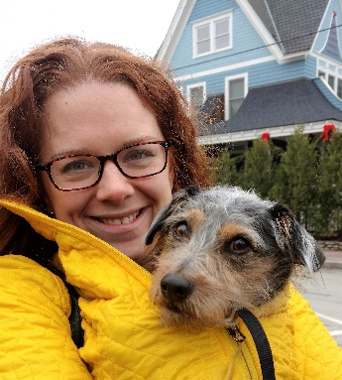
Filling out the team:
Staff: Daron Blake will be joining the Alliance as the Northeast Program Coordinator. She will provide program and administrative coordination to help ensure the delivery of quality programs for the northeast region, especially focused on the New York, all-volunteer land trusts, community conservation and training program areas. 40% of her time is dedicated for NY programs and this time is earmarked for activities that add capacity to our program!

Daron will be based in Saratoga Springs. She brings a background in communications and program support in the conservation field. Most recently, Daron worked for the Mohawk Hudson Land Conservancy, as the Communications and Outreach Coordinator. Her past work experience includes managing communications for The Nature Museum in Grafton, Vermont, and for Audubon International in Troy, New York.

Daron earned her B.S. in Environmental Studies from SUNY Binghamton and her M.A. in Environmental History from Kansas State University. Daron's first day is Monday, March 11

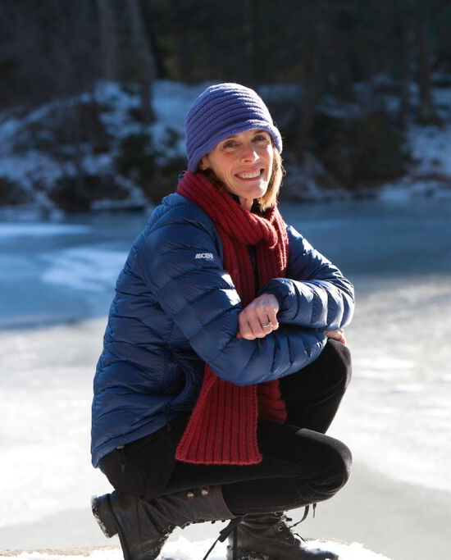
Circuit Rider: Connie Manes will be the Alliance’s NY Circuit Rider in 2019, providing coaching and accreditation preparation support to land trusts. She is the Principal of Manes Consulting, LLC and since 2008 has served as the part-time Executive Director of the Kent Land Trust, an accredited community-based land trust in Kent, CT. Connie also manages the Litchfield Hills Greenprint Collaborative, a Regional Conservation Partnership of more than 32 land trusts, conservation organizations, municipalities and corporations working together to expand the reach and impact of conservation work in Northwest CT.

As a private consultant, Connie has worked with many organizations to conduct assessments and implement business policies and procedures to improve performance, address risk, and enhance long-term sustainability. In 2012 she pioneered the growing national Land Trust Alliance Circuit Rider program working with nonprofits throughout Connecticut to prepare for land trust accreditation. She is now working with many of these organizations on their accreditation renewal applications. A graduate of Williams College, she earned her Juris Doctorate from New York University School of Law and her Master’s Degree in Public Administration from Pace University. She chairs the Advisory Council of the statewide Connecticut Land Conservation Council and the Town of Kent’s Conservation Commission.

Conference: Look for a full update at the March 6 Meeting. If you are working on sponsorships, please check in with Meme for any pending solicitations or if she can help in anyway.

